**NAMA : Ismail Wahyu Fadilah**

**NIM : 202010370311339**

**KELAS : RI C**

**Theme:**

ANTERINSINI

# Overview

**Project Brief:**

This project is about designing the user interface (UI) and user experience (UX) for the ANTERINSINI application, a software application that aims to help users to transport goods they want to queue or move.

The purpose of this project is to help people or boarding children in delivering their goods. Also in this application users can rent goods transport vehicles that have been provided in this application.

**Background:**

ANTERINSINI is an application that focuses on delivering goods that you want to drive to their destination. This application serves as planning, designing and developing an effective and useful expedition application for users. Also to always focus on user experience, content quality, and data security, but some user experience issues that need to be fixed have arisen. To increase the appeal, user engagement, and functionality of the app, this UI/UX design project began to be improved over time.

ANTERINSINI Target Users include various groups, including boarding children who have a lot of goods and are confused about what to use. Users who have problems because they want to move and are confused about moving their properties to a new place. Borrowing transportation equipment for moving goods is also provided in this application so that users can more freely carry their goods with the intended place. In this project, the main focus is improving user experience, more attractive visual appearance, and higher engagement in the use of the application.

Issues to be addressed include complicated navigation in the application, lack of active involvement from most use of transportation features, and problems related to unattractive visual appearance. With improvements in UI / UX aspects, Antersini hopes to increase user satisfaction, make it easier for boarding children to help move boarding houses, help move houses and move rents, also make this application the main choice for those who want to borrow transportation more easily through the application. This project aims to improve the overall user experience, making ANTERINSINI a more interesting, interactive, and relevant application for users in finding delivery and borrowing services for freight transportation vehicles.

**Research Success Criteria:**

|  |
| --- |
| * Increased user satisfaction in using ANTERIN Services * Helps make it easier for users to move goods * Users have higher engagement |

**Deliverables:**

|  |  |
| --- | --- |
| • | Documentation UI/UX evaluation report |
| • | Suggesting design improvements involves writing actionable recommendations to improve the user interface, navigation, and visual elements with the goal of improving the overall user experience. |

# Hypothesis

**Assumptions:**

|  |  |
| --- | --- |
| • | UI/UX design improvements will increase user engagement when using all features of the ANTERINSINI application, as shown by the increased frequency of sharing reviews and recommendations. |
| • | Improvements to UI/UX design will increase the level of user use of the app in the long run, which means users are likely to continue to use the app actively for a longer period of time. |

# Methods

**Qualitative Methods:**

|  |
| --- |
| Using in-depth interviews can provide a deeper understanding of a user's views and experience |

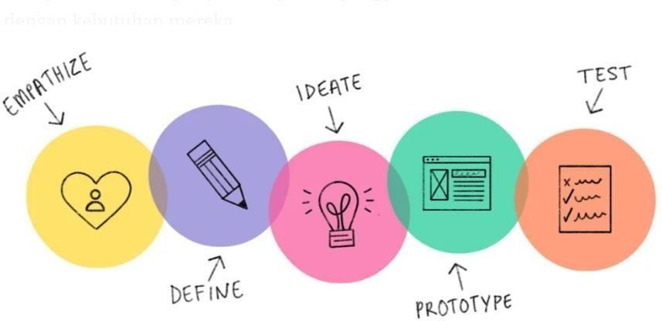

# Emphatize

This stage has been planned to deepen understanding the needs of users and guide me in making accurate decisions. In order to achieve this goal, I conduct interviews with users to gather the necessary information. In this way, I hope to dig deeper into the needs of users so as to design a suitable solution that suits and matches their needs.

User target :

1. Boarding people
2. People looking for freight forwarding service recommendations
3. People who need to move things by driving themselves
4. People who have smartphones

# **User Research**

## Responden #1

**Participant Information:**

Name: Meylinda

Age: 22 Years Old

Occupation: Student

**Warm-up Questions:**

1. How do you move your belongings to a new place?

Answer : Usually I move with the help of family and friends, but if they can't help because I can't lift it myself.

2. Do you like to move? If so, what helps you most when trying to move your stuff to a new place? Answer: yes I like to move boarding houses. I am helped if I am helped by a cheaper and affordable lifting aid service.

**Main Questions:**

1. Do you have difficulty moving goods using your vehicle? If so, mention the obstacle, where? Answer: yes I have a lot of trouble when I move my stuff on my bike. Because I was just alone, no one was holding my things.
2. What challenges or obstacles do you face with current methods of delivering goods? Answer: My obstacle when moving boarding and lifting goods is that it is difficult to find goods transportation services, even if it can also sometimes be difficult to confirm the place of moving because the delivery person does not know the destination
3. Are there any features that you want to be in the ANTERINSINI application?

Answer: I want the delivery service application to have a feature that allows me to order boarding children's freight forwarding services in a few simple and fast steps.

**Wrap-up:**

We greatly appreciate your time and contribution in this interview. The information you provide will be very useful in the development of UI / UX of our freight forwarding service application. If you have additional information or further questions, please let us know. If you have nothing else to say, we would like to thank you once again for your valuable participation in this research.

## Responden #2

**Participant Information:**

Nama: Hafiz

Age: 19 Years Old

Occupation: Student

**Warm-up Questions:**

1. How do you move your belongings to a new place?

' Answer: Usually if I want to move I borrow a car to a neighbor or to a boarding mother.

2. Do you like to move? If so, what helps you most when trying to move your stuff to a new place? Answer: I really like to move boarding houses, the most helpful is if I can order transportation to carry my goods without having to find a vehicle and borrow it.

**Main Questions:**

1. Do you have difficulty moving goods using your vehicle? If so, mention the obstacle, where? Answer: Yes, I usually have difficulty moving things to a new boarding house. The problem is because I don't have a vehicle
2. What challenges or obstacles do you face with current methods of delivering goods? Answer: My biggest challenge when delivering goods is because I have a vehicle, so I can't deliver my goods
3. Are there any features that you want to be in the ANTERINSINI application? Answer: I want the anter service booking application to have a transportation vehicle loan feature like the torrso that I need

**Wrap-up:**

We greatly appreciate your time and contribution in this interview. The information you provide will be very useful in the development of UI / UX of our freight forwarding service application. If you have additional information or further questions, please let us know. If you have nothing else to say, we would like to thank you once again for your valuable participation in this research.

## Responden #3

**Participant Information:**

Nama: Valen

Age: 21 Years Old

Occupation: Student

**Warm-up Questions:**

1. How do you move your belongings to a new place?

' Answer: Usually I move by myself using my bike

2. Do you like to move? If so, what helps you most when trying to move your stuff to a new place? Answer: Yes, I usually move to move boarding houses, the thing that helps me the most is that if there are friends who have a car, they can ask for help.

**Main Questions:**

1. Do you have difficulty moving goods using your vehicle? If so, mention the obstacle, where? Answer: Yes I am very difficult, if there are no friends to help I am forced to order gocar services which are very expensive I also have to lift myself
2. What challenges or obstacles do you face with current methods of delivering goods? Answer: My biggest challenge when using a delivery service is that it is difficult to carry my goods with the vehicle I want because the feature only tells the contents of any item instead of choosing a vehicle that can be used to transport goods.
3. Are there any features that you want to be in the ANTERINSINI application? Answer: I would like there to be a feature that can choose a borrowed vehicle from a moving service

**Wrap-up:**

We greatly appreciate your time and contribution in this interview. The information you provide will be very useful in the development of UI / UX of our freight forwarding service application. If you have additional information or further questions, please let us know. If you have nothing else to say, we would like to thank you once again for your valuable participation in this research.

## Responden #4

**Participant Information:**

Nama: Fariz

Age: 22 Years Old

Occupation: Student

**Warm-up Questions:**

1. How do you move your belongings to a new place?

' Answer: Usually I move by myself, in installments.

2. Do you like to move? If so, what helps you most when trying to move your stuff to a new place? Answer: I like to move every 6 months when my boarding period is up. The most helpful freight forwarding services that can track our goods. So we no longer need to guide the delivery service, just need to go first to the destination and wait.

**Main Questions:**

1. Do you have difficulty moving goods using your vehicle? If so, mention the obstacle, where? Answer: Yes it is difficult because my small vehicle does not load all my belongings
2. What challenges or obstacles do you face with current methods of delivering goods? Answer: My obstacle is that it takes a long time when ordering freight forwarding services to arrive late
3. Are there any features that you want to be in the ANTERINSINI application? Answer: features that if you pay easily can COD and can pay later, because if I want to move money again, there is no one so confused about how to transport goods.

**Wrap-up:**

We greatly appreciate your time and contribution in this interview. The information you provide will be very useful in the development of UI / UX of our freight forwarding service application. If you have additional information or further questions, please let us know. If you have nothing else to say, we would like to thank you once again for your valuable participation in this research.

## Responden #5

**Participant Information:**

Name: Yoga

Age: 21 Years Old

Occupation: Student

**Warm-up Questions:**

1. How do you move your belongings to a new place?

' Answer: Usually I pay in installments so it takes a long time to prepare for the move

2. Do you like to move? If so, what helps you most when trying to move your stuff to a new place? Answer: I do sometimes move but every 3 months, I am helped to move if there are friends who want to help use their vehicle.

**Main Questions:**

* 1. Do you have difficulty moving goods using your vehicle? If so, mention the obstacle, where? Answer: I have difficulty when carrying goods using a motorbike because my motorbike has no space to put things
  2. What challenges or obstacles do you face with current methods of delivering goods? Answer: the difficulty in ordering anter services sometimes there are no employees who can deliver because the employees are off.
  3. Are there any features that you want to be in the ANTERINSINI application? Answer: I want a feature that can make payments using Q-Ris because I don't have cash sometimes.

**Wrap-up:**

We greatly appreciate your time and contribution in this interview. The information you provide will be very useful in the development of UI / UX of our freight forwarding service application. If you have additional information or further questions, please let us know. If you have nothing else to say, we would like to thank you once again for your valuable participation in this research.

### Define

At this stage, we combine previously collected data to design solutions that can help users lead a healthy lifestyle. This step focuses on using information about user needs and preferences to ensure that the resulting solution is fit for purpose and effective in meeting their needs.

User Persona

### Designed

In the initial step of designing solutions to overcome previously identified problems, a number of activities are carried out, including developing solution ideas, grouping similar ideas using the affinity diagram method, and setting priorities on the ideas generated.

Solution Idea

After generating solution ideas, I grouped them into one category, namely Explore new lifestyles

**EXPLORE DELIVERY SERVICES**

Affinity Diagram

After grouping similar ideas using an affinity diagram, the next step is to prioritize them by creating a list based on their importance, which is referred to as idea prioritization. The goal is to focus on the most vital ideas and provide the greatest benefit to users. By prioritizing these ideas, I can use resources and time more efficiently to develop optimal solutions according to user needs.

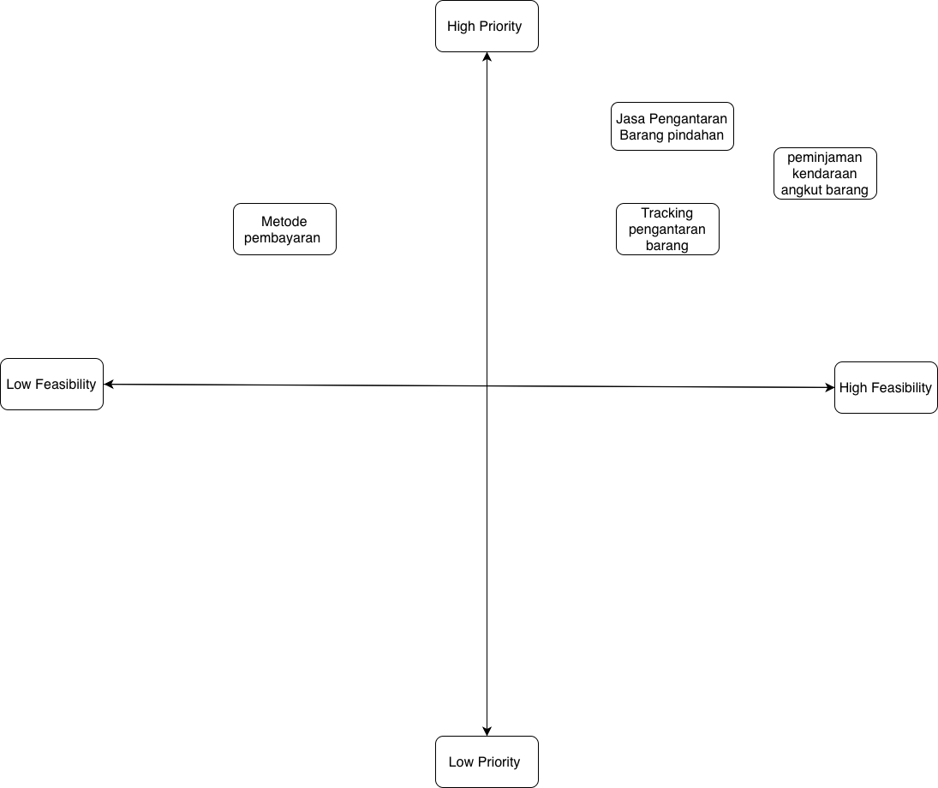

Prioritization Idea

#### Prototype

In this stage, I will create a simple application interface design to give a clear picture of how users will use the application. The goal is to ensure that the application design plan can be properly implemented as an interface that is easy for users to understand. Using wireframes, I can evaluate design ideas and determine improvements that need to be made before developing a more complete prototype version.

Prototype

After creating a wireframe to illustrate how the user will interact with the application, the next step is to create a user interface design (UI design) that features a realistic and user-friendly interface. At this stage, I'll combine design elements such as colors, typography, icons, and images to create an attractive and user-friendly look for users. The goal is to create an application interface that can be easily understood by users, enticing them to continue using the application. Through UI design, I can ensure that the app has a consistent and professional look and feel, and provides an optimal user experience.

Main Page Delivery Service Page

Freight Forwarding Tracking Page Transport Vehicle Loan Page

App Payment Balance Page

UsabilityTesting

In the final stage, I used Maze.co website to test how users interact with the app service. The goal is to help the design team assess the extent to which the service is easy for users to use.

Link Maze : <https://t.maze.co/211078086>

Link Report : <https://app.maze.co/report/Project-C/29c5ulqvb7w9j/intro>

1. Test Prototype pertama

1. Second Test Prototype

1. Third Test Prototype

1. Fourth Test Prototype

